Министерство образования Республики Беларусь

Учреждение образования

«Брестский Государственный технический университет»

Кафедра ИИТ

**Лабораторная работа №6**

По дисциплине «Аппаратное и программное обеспечение сетей»

Тема: «Настройка динамической маршрутизации с помощью протокола RIP на устройствах Cisco»

**Выполнил:**

Студент 3 курса

Группы ИИ-21

Пучинский А.А.

**Проверил:**

Степанчук В.И.

Брест 2023

**Цель работы:** Настроить динамическую маршрутизацию с помощью протокола RIP на устройствах R1,R2, R3. Обеспечить возможность взаимодействия конечных устройств PC1, PC2, PC3 между собой.

**Ход работы:**

**Вариант 6**

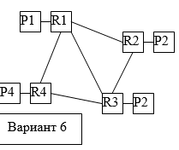

1. Загрузив lab5-b.pdf, изучить материал; выполнить этапы настройки динамической маршрутизации с помощью протокола RIP на устройствах Cisco, изложенные в документе. По требованию преподавателя продемонстрировать правильность настройки.

2. Собрать **схему сети согласно выданному варианту задания**; распределить IP-адреса по аналогии с примером в lab5-b.pdf; составить таблицу сетевых адресов; сконфигурировать устройства.

3. **Для собранной схемы сети** выполнить настройку динамической маршрутизации с помощью протокола RIP.

В отчете привести:

- схему сети

- таблицу IP-адресов

- ход настройки маршрута по протоколу RIP по методике, приведенной в Lab5-b.pdf

- ход и результаты проверки и тестирования сети по методике, приведенной в lab5-b.pdf.

**1.**

**Таблица сети:**

|  |  |  |  |  |
| --- | --- | --- | --- | --- |
| **Device** | **Interface** | **IP Address** | **Mask** | **Default Gateway** |
| **R1** | **Fa0/0** | 192.168.1.1 | 255.255.255.0 | N/A |
| **Fa0/1** | 10.0.0.1 | 255.255.255.252 | N/A |
| **Se0/0/0** | 10.0.0.9 | 255.255.255.252 | N/A |
| **R2** | **Fa0/0** | 192.168.2.1 | 255.255.255.0 | N/A |
| **Fa0/1** | 10.0.0.2 | 255.255.255.252 | N/A |
| **Se0/0/1** | 10.0.0.6 | 255.255.255.252 | N/A |
| **R3** | **Fa0/0** | 192.168.3.1 | 255.255.255.0 | N/A |
| **Se0/0/0** | 10.0.0.10 | 255.255.255.252 | N/A |
| **Se0/0/1** | 10.0.0.5 | 255.255.255.252 | N/A |
| **PC1** | **N/A** | 192.168.1.10 | 255.255.255.0 | 192.168.1.1 |
| **PC2** | **N/A** | 192.168.2.10 | 255.255.255.0 | 192.168.2.1 |
| **PC3** | **N/A** | 192.168.3.10 | 255.255.255.0 | 192.168.3.1 |

**Топология сети:**

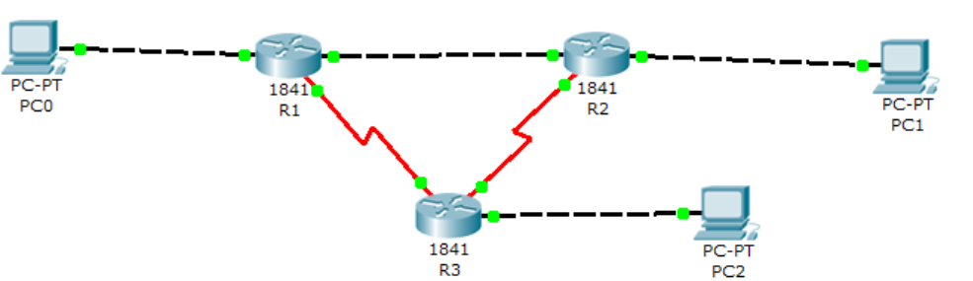

**Настройка сети:**

R1(config)#router rip

R1(config-router)#network 192.168.1.0

R1(config-router)#network 10.0.0.0

R2(config)#router rip

R2(config-router)#network 192.168.2.0

R2(config-router)#network 10.0.0.0

R3(config)#router rip

R3(config-router)#network 192.168.3.0

R3(config-router)#network 10.0.0.0

**Тестирование сети:**

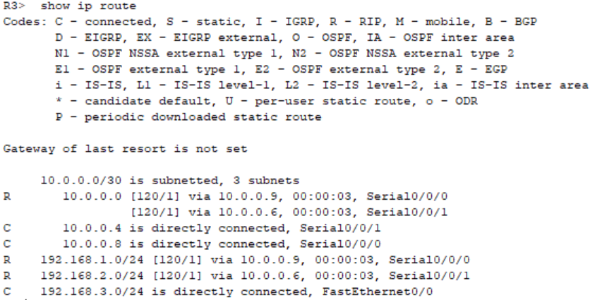

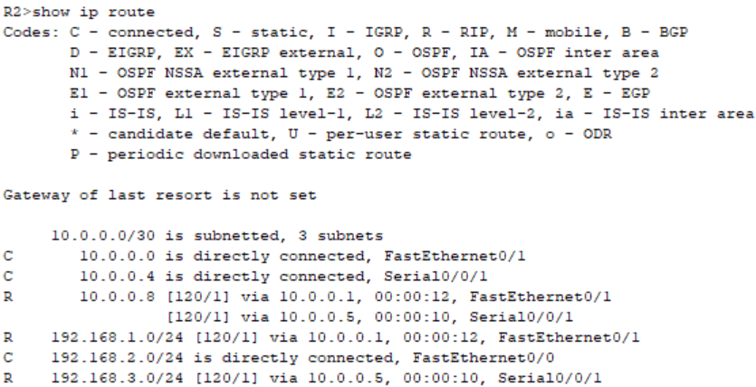

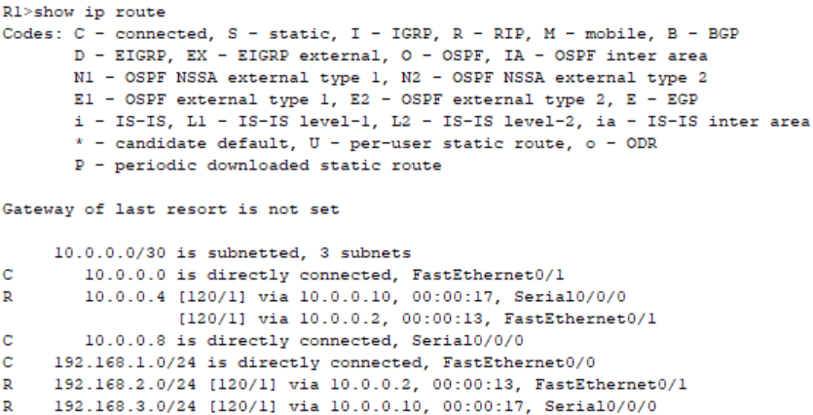

**2.**

**Таблица сети:**

|  |  |  |  |  |
| --- | --- | --- | --- | --- |
| **Device** | **Interface** | **IP Address** | **Mask** | **Default Gateway** |
| **R1** | **Fa0/0** | 192.168.1.1 | 255.255.255.0 | N/A |
| **S0/0** | 10.0.0.5 | 255.255.255.252 | N/A |
| **S0/1** | 10.0.0.25 | 255.255.255.252 | N/A |
| **S0/2** | 10.0.0.9 | 255.255.255.252 | N/A |
| **R2** | **Fa0/0** | 192.168.2.1 | 255.255.255.0 | N/A |
| **S0/0** | 10.0.0.6 | 255.255.255.252 | N/A |
| **S0/1** | 10.0.0.13 | 255.255.255.252 | N/A |
| **S0/2** | 10.0.0.17 | 255.255.255.252 | N/A |
| **R3** | **Fa0/0** | 192.168.3.1 | 255.255.255.0 | N/A |
| **S0/0** | 10.0.0.21 | 255.255.255.252 | N/A |
| **S0/1** | 10.0.0.14 | 255.255.255.252 | N/A |
| **S0/2** | 10.0.0.10 | 255.255.255.252 | N/A |
| **R4** | **Fa0/0** | 192.168.4.1 | 255.255.255.0 | N/A |
| **S0/0** | 10.0.0.22 | 255.255.255.252 | N/A |
| **S0/1** | 10.0.0.26 | 255.255.255.252 | N/A |
| **S0/2** | 10.0.0.18 | 255.255.255.252 | N/A |
| **PC1** | **N/A** | 192.168.1.10 | 255.255.255.0 | 192.168.1.1 |
| **PC2** | **N/A** | 192.168.2.10 | 255.255.255.0 | 192.168.2.1 |
| **PC3** | **N/A** | 192.168.3.10 | 255.255.255.0 | 192.168.3.1 |
| **PC4** | **N/A** | 192.168.4.10 | 255.255.255.0 | 192.168.4.1 |

**Топология сети:**

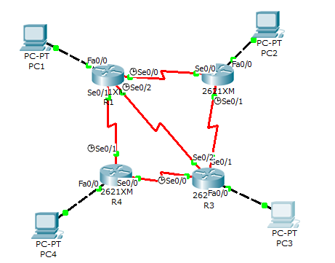

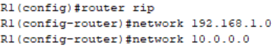

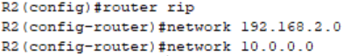

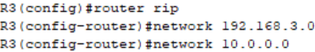



**Тестирование сети:**

R1>show ip route

Codes: C - connected, S - static, I - IGRP, R - RIP, M - mobile, B - BGP

D - EIGRP, EX - EIGRP external, O - OSPF, IA - OSPF inter area

N1 - OSPF NSSA external type 1, N2 - OSPF NSSA external type 2

E1 - OSPF external type 1, E2 - OSPF external type 2, E - EGP

i - IS-IS, L1 - IS-IS level-1, L2 - IS-IS level-2, ia - IS-IS inter area

* - candidate default, U - per-user static route, o - ODR

P - periodic downloaded static route

Gateway of last resort is not set

10.0.0.0/30 is subnetted, 6 subnets

C 10.0.0.4 is directly connected, Serial0/0

C 10.0.0.8 is directly connected, Serial0/2

R 10.0.0.12 [120/1] via 10.0.0.6, 00:00:25, Serial0/0

[120/1] via 10.0.0.10, 00:00:01, Serial0/2

R 10.0.0.16 is possibly down, routing via 10.0.0.26, Serial0/1

R 10.0.0.20 [120/1] via 10.0.0.26, 00:00:17, Serial0/1

[120/1] via 10.0.0.10, 00:00:01, Serial0/2

C 10.0.0.24 is directly connected, Serial0/1

C 192.168.1.0/24 is directly connected, FastEthernet0/0

R 192.168.2.0/24 [120/1] via 10.0.0.6, 00:00:25, Serial0/0

R 192.168.3.0/24 [120/1] via 10.0.0.10, 00:00:01, Serial0/2

R 192.168.4.0/24 [120/1] via 10.0.0.26, 00:00:17, Serial0/1

R2>show ip route

Codes: C - connected, S - static, I - IGRP, R - RIP, M - mobile, B - BGP

D - EIGRP, EX - EIGRP external, O - OSPF, IA - OSPF inter area

N1 - OSPF NSSA external type 1, N2 - OSPF NSSA external type 2

E1 - OSPF external type 1, E2 - OSPF external type 2, E - EGP

i - IS-IS, L1 - IS-IS level-1, L2 - IS-IS level-2, ia - IS-IS inter area

* - candidate default, U - per-user static route, o - ODR

P - periodic downloaded static route

Gateway of last resort is not set

10.0.0.0/30 is subnetted, 5 subnets

C 10.0.0.4 is directly connected, Serial0/0

R 10.0.0.8 [120/1] via 10.0.0.5, 00:00:04, Serial0/0

[120/1] via 10.0.0.14, 00:00:09, Serial0/1

C 10.0.0.12 is directly connected, Serial0/1

R 10.0.0.20 [120/1] via 10.0.0.14, 00:00:09, Serial0/1

R 10.0.0.24 [120/1] via 10.0.0.5, 00:00:04, Serial0/0

R 192.168.1.0/24 [120/1] via 10.0.0.5, 00:00:04, Serial0/0

C 192.168.2.0/24 is directly connected, FastEthernet0/0

R 192.168.3.0/24 [120/1] via 10.0.0.14, 00:00:09, Serial0/1

R 192.168.4.0/24 [120/2] via 10.0.0.14, 00:00:09, Serial0/1

[120/2] via 10.0.0.5, 00:00:04, Serial0/0

R3>show ip route

Codes: C - connected, S - static, I - IGRP, R - RIP, M - mobile, B - BGP

D - EIGRP, EX - EIGRP external, O - OSPF, IA - OSPF inter area

N1 - OSPF NSSA external type 1, N2 - OSPF NSSA external type 2

E1 - OSPF external type 1, E2 - OSPF external type 2, E - EGP

i - IS-IS, L1 - IS-IS level-1, L2 - IS-IS level-2, ia - IS-IS inter area

* - candidate default, U - per-user static route, o - ODR

P - periodic downloaded static route

Gateway of last resort is not set

10.0.0.0/30 is subnetted, 5 subnets

R 10.0.0.4 [120/1] via 10.0.0.13, 00:00:14, Serial0/1

[120/1] via 10.0.0.9, 00:00:16, Serial0/2

C 10.0.0.8 is directly connected, Serial0/2

C 10.0.0.12 is directly connected, Serial0/1

C 10.0.0.20 is directly connected, Serial0/0

R 10.0.0.24 [120/1] via 10.0.0.22, 00:00:07, Serial0/0

[120/1] via 10.0.0.9, 00:00:16, Serial0/2

R 192.168.1.0/24 [120/1] via 10.0.0.9, 00:00:16, Serial0/2

R 192.168.2.0/24 [120/1] via 10.0.0.13, 00:00:14, Serial0/1

C 192.168.3.0/24 is directly connected, FastEthernet0/0

R 192.168.4.0/24 [120/1] via 10.0.0.22, 00:00:07, Serial0/0

R4>show ip route

Codes: C - connected, S - static, I - IGRP, R - RIP, M - mobile, B - BGP

D - EIGRP, EX - EIGRP external, O - OSPF, IA - OSPF inter area

N1 - OSPF NSSA external type 1, N2 - OSPF NSSA external type 2

E1 - OSPF external type 1, E2 - OSPF external type 2, E - EGP

i - IS-IS, L1 - IS-IS level-1, L2 - IS-IS level-2, ia - IS-IS inter area

* - candidate default, U - per-user static route, o - ODR

P - periodic downloaded static route

Gateway of last resort is not set

10.0.0.0/30 is subnetted, 5 subnets

R 10.0.0.4 [120/1] via 10.0.0.25, 00:00:22, Serial0/1

R 10.0.0.8 [120/1] via 10.0.0.25, 00:00:22, Serial0/1

[120/1] via 10.0.0.21, 00:00:03, Serial0/0

R 10.0.0.12 [120/1] via 10.0.0.21, 00:00:03, Serial0/0

C 10.0.0.20 is directly connected, Serial0/0

C 10.0.0.24 is directly connected, Serial0/1

R 192.168.1.0/24 [120/1] via 10.0.0.25, 00:00:22, Serial0/1

R 192.168.2.0/24 [120/2] via 10.0.0.21, 00:00:03, Serial0/0

[120/2] via 10.0.0.25, 00:00:22, Serial0/1

R 192.168.3.0/24 [120/1] via 10.0.0.21, 00:00:03, Serial0/0

C 192.168.4.0/24 is directly connected, FastEthernet0/0

PC>ping 192.168.2.10

Pinging 192.168.2.10 with 32 bytes of data:

Request timed out.

Reply from 192.168.2.10: bytes=32 time=94ms TTL=126

Reply from 192.168.2.10: bytes=32 time=95ms TTL=126

Reply from 192.168.2.10: bytes=32 time=95ms TTL=126

Ping statistics for 192.168.2.10:

Packets: Sent = 4, Received = 3, Lost = 1 (25% loss),

Approximate round trip times in milli-seconds:

Minimum = 94ms, Maximum = 95ms, Average = 94ms

PC>ping 192.168.3.10

Pinging 192.168.3.10 with 32 bytes of data:

Request timed out.

Reply from 192.168.3.10: bytes=32 time=95ms TTL=126

Reply from 192.168.3.10: bytes=32 time=78ms TTL=126

Reply from 192.168.3.10: bytes=32 time=96ms TTL=126

Ping statistics for 192.168.3.10:

Packets: Sent = 4, Received = 3, Lost = 1 (25% loss),

Approximate round trip times in milli-seconds:

Minimum = 78ms, Maximum = 96ms, Average = 89ms

PC>ping 192.168.4.10

Pinging 192.168.4.10 with 32 bytes of data:

Request timed out.

Reply from 192.168.4.10: bytes=32 time=95ms TTL=126

Reply from 192.168.4.10: bytes=32 time=93ms TTL=126

Reply from 192.168.4.10: bytes=32 time=94ms TTL=126

Ping statistics for 192.168.4.10:

Packets: Sent = 4, Received = 3, Lost = 1 (25% loss),

Approximate round trip times in milli-seconds:

Minimum = 93ms, Maximum = 95ms, Average = 94ms

**Вывод:** Настроил динамическую маршрутизацию с помощью протокола RIP на устройствах R1,R2, R3. Обеспечил возможность взаимодействия конечных устройств PC1, PC2, PC3 между собой.